MAD LAB CYCLE -2

**1.** **Create 2 Activities from 1st Activity on click move to 2nd activity (Using Intent)**

**Program code:**

**Xml code**

**Activity_main.xml:**

*<?***xml version="1.0" encoding="utf-8"***?>*

<**LinearLayout xmlns:android="http://schemas.android.com/apk/res/android"**

**android:id="@+id/activity_main"**

**android:layout_width="match_parent"**

**android:layout_height="match_parent"**

**android:orientation="vertical"**>

<**TextView**

**android:layout_width="match_parent"**

**android:layout_height="wrap_content"**

**android:text="First Activity"**

**android:textStyle="bold"**

**android:layout_marginTop="10dp"**

**android:textAlignment="center"**

**style="@style/Animation.AppCompat.Dialog"**

**android:textSize="30dp"**/>

<**Button**

**android:text="Click Me"**

**android:layout_width="match_parent"**

**android:layout_height="wrap_content"**

**android:id="@+id/button"**

**android:onClick="click"**

**android:textStyle="bold"**

**android:layout_marginTop="200dp"**

**android:background="#34eb3a"**

**android:textSize="30dp"**/>

</**LinearLayout**>

**Activity2_main.xml:**

*<?***xml version="1.0" encoding="utf-8"***?>*

<**LinearLayout xmlns:android="http://schemas.android.com/apk/res/android"**

**android:id="@+id/activity_main2"**

**android:layout_width="match_parent"**

**android:layout_height="match_parent"**

**android:orientation="vertical"**>

<**TextView**

**android:layout_width="match_parent"**

**android:layout_height="wrap_content"**

**android:text="Second Activity"**

**android:textStyle="bold"**

**android:layout_marginTop="10dp"**

**android:textSize="30dp"**

**android:textAlignment="center"**/>

<**Button**

**android:text="Go Back"**

**android:layout_width="match_parent"**

**android:layout_height="wrap_content"**

**android:id="@+id/button2"**

**android:onClick="clickback"**

**android:textSize="30dp"**

**android:background="#34eb3a"**

**android:layout_marginTop="200dp"**/>

</**LinearLayout**>

**Java**

**Activity_main.java:**

**package** com.example.sjcet.pgm1_2activity;

**import** android.content.Intent;

**import** android.support.v7.app.AppCompatActivity;

**import** android.os.Bundle;

**import** android.view.View;

**public class** MainActivity **extends** AppCompatActivity {

@Override

**protected void** onCreate(Bundle savedInstanceState) {

**super**.onCreate(savedInstanceState);

setContentView(R.layout.***activity_main***);

}

**public void** click(View view) {

Intent intent = **new** Intent(MainActivity.**this**, Main2Activity.**class**);

startActivity(intent);

}

}

**Activity2_main.java:**

**package** com.example.sjcet.pgm1_2activity;

**import** android.content.Intent;

**import** android.support.v7.app.AppCompatActivity;

**import** android.os.Bundle;

**import** android.view.View;

**public class** Main2Activity **extends** AppCompatActivity {

@Override

**protected void** onCreate(Bundle savedInstanceState) {

**super**.onCreate(savedInstanceState);

setContentView(R.layout.***activity_main2***);

}

**public void** clickback(View view) {

Intent intent = **new** Intent(Main2Activity.**this**, MainActivity.**class**);

startActivity(intent);

}

}

**Output**

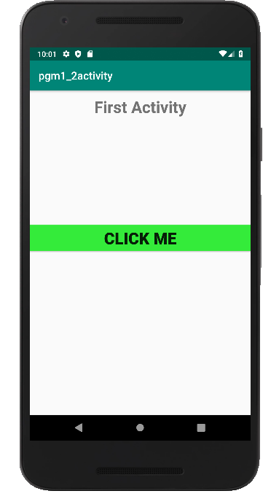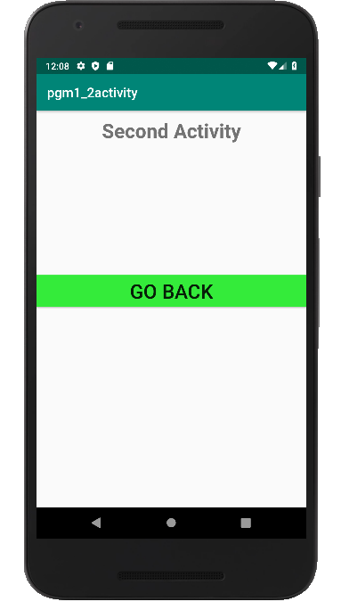

**2. Create an Activity and move to facebook login page on a button click**

**(making use of Intent).**

**Program code:**

**Xml code**

**Activity_main.xml:**

*<?***xml version="1.0" encoding="utf-8"***?>*

<**LinearLayout android:layout_width="match_parent"**

**android:layout_height="match_parent"**

**android:orientation="vertical"**

**xmlns:android="http://schemas.android.com/apk/res/android"**>

<**Button**

**android:onClick="click"**

**android:layout_width="wrap_content"**

**android:layout_height="wrap_content"**

**android:text="Facebook login"**

**android:layout_centerInParent="true"**

**android:textAlignment="center"**

**android:layout_gravity="center"**

**android:background="#006aff"**

**android:textColor="#fff"**/>

</**LinearLayout**>

**Java**

**Activity_main.java:**

**package** com.example.sjcet.pgm2_fbpage;

**import** android.content.Intent;

**import** android.net.Uri;

**import** android.support.v7.app.AppCompatActivity;

**import** android.os.Bundle;

**import** android.view.View;

**public class** MainActivity **extends** AppCompatActivity {

@Override

**protected void** onCreate(Bundle savedInstanceState) {

**super**.onCreate(savedInstanceState);

setContentView(R.layout.***activity_main***);

}

**public void** click(View view) {

String url = **"https://www.facebook.com"**;

Intent i = **new** Intent(Intent.***ACTION_VIEW***);

i.setData(Uri.*parse*(url));

startActivity(i);

}

}

**Output**

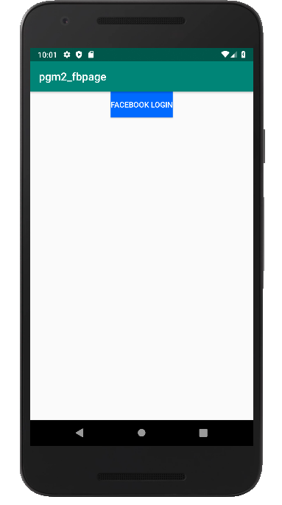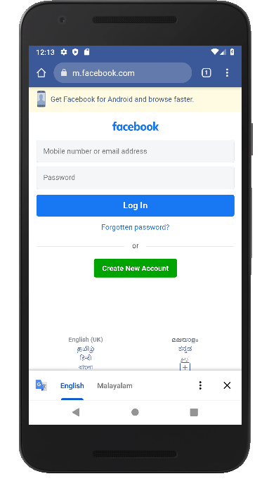

**3. Read message from 1st Activity and pass it onto the 2nd Activity on a button click.**

**Xml code**

**Activity_main.xml:**

***<?*xml version="1.0" encoding="utf-8"*?>***

<**LinearLayout xmlns:android="http://schemas.android.com/apk/res/android"**

**android:id="@+id/activity_main"**

**android:layout_width="match_parent"**

**android:layout_height="match_parent"**

**android:orientation="vertical"**>

<**TextView**

**android:layout_width="match_parent"**

**android:layout_height="wrap_content"**

**android:text="First Activity"**

**android:textStyle="bold"**

**android:layout_marginTop="10dp"**

**android:textAlignment="center"**

**android:textSize="30dp"**/>

<**EditText**

**android:layout_width="match_parent"**

**android:layout_height="wrap_content"**

**android:hint="Text"**

**android:textColor="#000000"**

**android:textSize="20dp"**

**android:textStyle="bold"**

**android:id="@+id/text"** />

<**Button**

**android:text="Click here"**

**android:layout_width="match_parent"**

**android:layout_height="wrap_content"**

**android:id="@+id/button"**

**android:onClick="click"**

**android:textStyle="bold"**

**android:textSize="30dp"**

**android:background="#ff00ae"**

**android:textColor="#fff"**

**android:layout_gravity="center_vertical"** />

</**LinearLayout**>

**Activity2_main.xml:**

***<?*xml version="1.0" encoding="utf-8"*?>***

<**LinearLayout xmlns:android="http://schemas.android.com/apk/res/android"**

**android:id="@+id/activity_main2"**

**android:layout_width="match_parent"**

**android:layout_height="match_parent"**

**android:orientation="vertical"**>

<**TextView**

**android:layout_width="match_parent"**

**android:layout_height="wrap_content"**

**android:text="Second Activity"**

**android:textStyle="bold"**

**android:layout_marginTop="10dp"**

**android:textAlignment="center"**

**android:textSize="30dp"**/>

<**TextView**

**android:layout_width="match_parent"**

**android:layout_height="wrap_content"**

**android:textSize="30dp"**

**android:textColor="#000000"**

**android:id="@+id/textreceived"**

/>

<**Button**

**android:text="Go Back"**

**android:layout_width="match_parent"**

**android:layout_height="wrap_content"**

**android:id="@+id/button2"**

**android:textSize="30dp"**

**android:background="#ff00ae"**

**android:onClick="click"**/>

</**LinearLayout**>

**Java**

**Activity_main.java:**

**package com.example.sjcet.pgm3_copymsg;**

**import** android.content.Intent;

**import** android.support.v7.app.AppCompatActivity;

**import** android.os.Bundle;

**import** android.view.View;

**import** android.widget.Button;

**import** android.widget.EditText;

**public class** MainActivity **extends** AppCompatActivity {

EditText **text**;

Button **clickme**;

String **Texthere**;

@Override

**protected void** onCreate(Bundle savedInstanceState) {

**super**.onCreate(savedInstanceState);

setContentView(R.layout.***activity_main***);

**clickme** = findViewById(R.id.***button***);

**text** = findViewById(R.id.***text***);

**clickme**.setOnClickListener(**new** View.OnClickListener() {

@Override

**public void** onClick(View v) {

**Texthere** = **text**.getText().toString();

Intent intent = **new** Intent(MainActivity.**this**, Main2Activity.**class**);

intent.putExtra(**"Text"**, **Texthere**);

startActivity(intent);

}

});

}

}

**Activity2_main.java:**

**package com.example.sjcet.pgm3_copymsg;**

**import** android.content.Intent;

**import** android.support.v7.app.AppCompatActivity;

**import** android.os.Bundle;

**import** android.view.View;

**import** android.widget.Button;

**import** android.widget.TextView;

**public class** Main2Activity **extends** AppCompatActivity {

TextView **textreceived**;

Button **button2**;

String **text**;

@Override

**protected void** onCreate(Bundle savedInstanceState) {

**super**.onCreate(savedInstanceState);

setContentView(R.layout.***activity_main2***);

**text** = getIntent().getExtras().getString(**"Text"**);

**textreceived** = findViewById(R.id.***textreceived***);

**textreceived**.setText(**text**);

**button2** = findViewById(R.id.***button2***);

**button2**.setOnClickListener(**new** View.OnClickListener() {

@Override

**public void** onClick(View v) {

Intent intent = **new** Intent(Main2Activity.**this**, MainActivity.**class**);

startActivity(intent);

}

});

}

}

**Output**

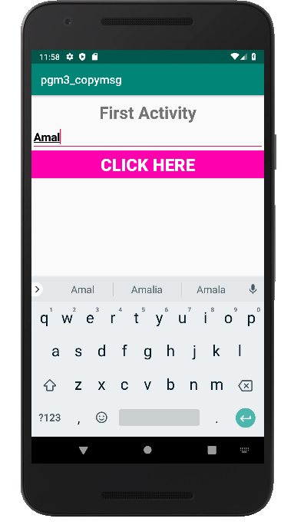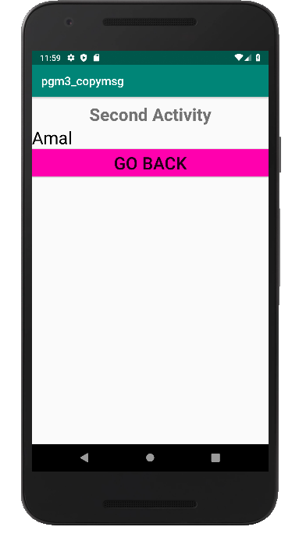

**4.Create registration page with full validation and pass the information to the second activity (using shared preference)**

**Mandatory fields : fname,lname,gender,email,phone number,password,dob(date picker)**

**Program code:**

**Xml code**

**Activity_main.xml:**

**Activity2_main.xml:**

**Java**

**Activity_main.java:**

**Activity2_main.java:**

**Output**